# TWM – TracePQM Wattmeter

V1.0, 2017-11-20

TWM is open source project that is being developed for transparent traceable measurement of electric power and power quality parameters. It is being developed in scope of EMPIR project TracePQM [1].

It consists of two parts: (i) LabVIEW control module and GUI and (ii) Octave/Matlab calculation module. Control module (i) handles the HW, i.e. records the waveforms, selects correction files and initiates calculation of the parameters using control module. Calculation module (ii) is based in the QWTB toolbox [2] and it runs in either Matlab or GNU Octave. Both parts are integrated together.

## File formats

For documentation of the file formats generated by the TWM, see attached files in project ‘doc’ folder.

## Supported HW

TWM currently integrates drivers for control of: (i) PXI 5922 digitizer using National Instrument’s niScope and niTClk drivers (must be installed on the computer); (ii) Sampling multimeters 3458A (NI’s VISA drivers must be installed); (iii) DirectSound Drivers for handling soundcard as an ADC [3]; (iv) Simulated ADC which can generate composite harmonics signal. Note the DirectSound drivers (iii) are implemented only for demonstration purposes so the TWM can be run even without any external HW. It may be usable for low accuracy measurements, however it is not official part of the TracePQM project.

## GNU Octave/Matlab interface

Goal of the project TracePQM is to implement interface between TWM and Matlab/GNU Octave so the calculations can run transparently in the M-functions. At the current version only interface to GNU Octave is implemented (GOLPI library [4]). Current version of the interface was tested with GNU Octave 4.0.0 and later however it should be possible to run it at least from version 3.6.4.

## Brief TWM documentation

The TWM is still in the development and all its functionality is subject to change. At the end of the project, the TWM will be documented with all the details. Following text describes only very basic usage of the current version.

Main panel of the TWM is shown in the Fig. 1. It contains several configuration buttons for configuration of the TWM components which will be described later. The button ‘VIEW RECORD’ can be used to view the last recorded waveform(s). The button ‘STOP’ is ungrayed whenever the TWM is busy and can be used to terminated the pending operation(s). Note it may take some time to respond on the STOP signal. Button ‘CORR’ will invoke panel for selecting the correction files. Note the corrections are not fully implemented in the current version, so the panel won’t be described.

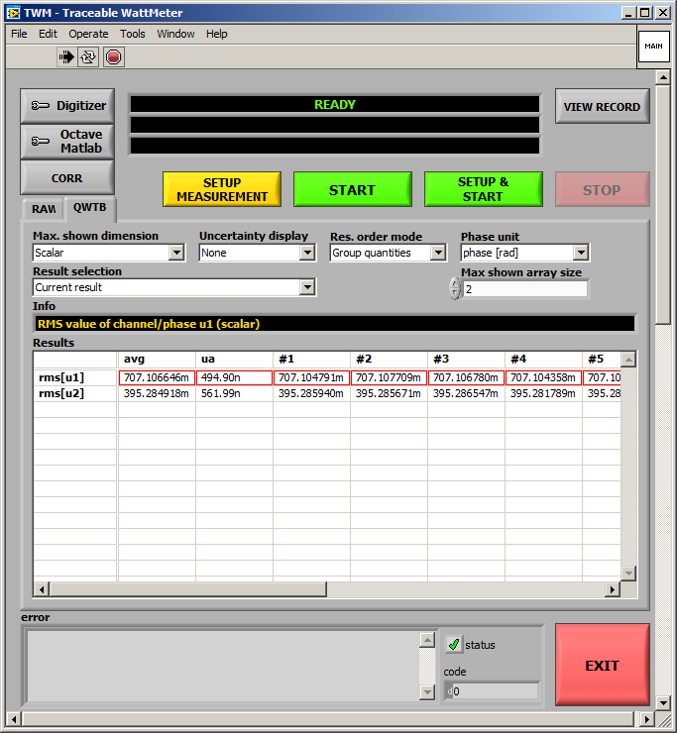

Fig. 1 - TWM's main panel

First, the digitizer HW must be configured. The button ‘Digitizer’ must be pressed in order to invoke Digitizer configuration panel. Example of the panels for niScope and 3458A digitizers are shown in the Fig. 2 and Fig. 3. The panel contains digitizer type selector which is used to select the HW to be used for the digitizing. Next, the virtual channels list must be filled in. The drives of 5922 (niScope) and 3458A are designed so the user can enter any count of channels. For 3458A, user must also select synchronization mode and sampling mode of the multimeters. Information panel on the left shows description of the selected mode. If the selected mode requires additional HW such as arbitrary waveform generator (AWG) or a counter the corresponding entries will be ungrayed and must be filled. Note both 5922 and 3458A have option ‘streaming’ which is the mode in which the sample data are streamed directly to the file and the internal memory of the digitizer is not used. This mode will extend the maximum number of samples to record. Each digitizer has ‘TEST’ function available. The ‘TEST’ button will initialize the HW and detect eventual errors which will be shown in the black box. If the test is successful, the black box will contain identifiers of the HW. If the digitizer support self-calibration procedure, the button ‘SELF-CAL’ will be ungrayed.

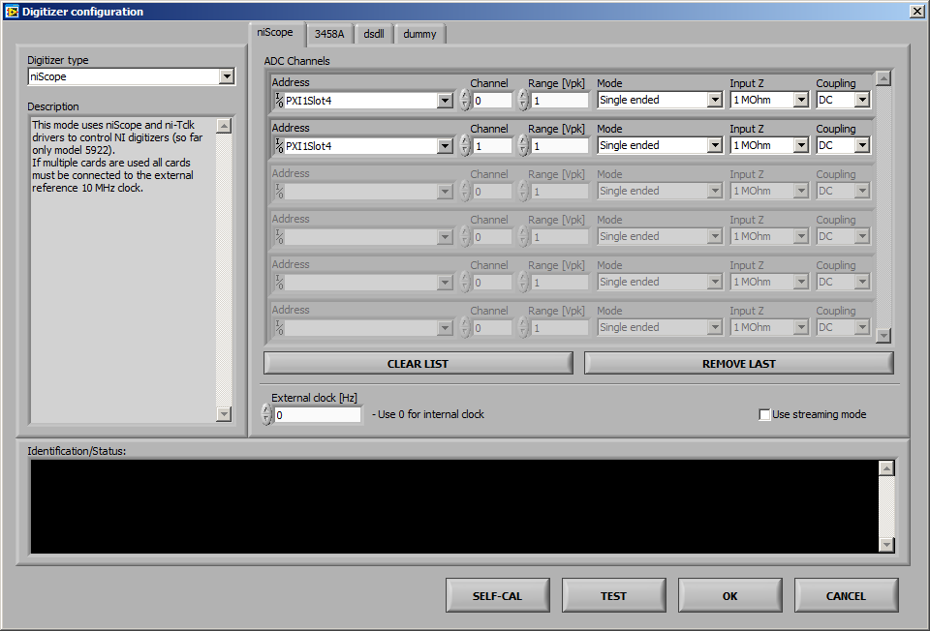

Fig. 2 - niScope configuration panel.

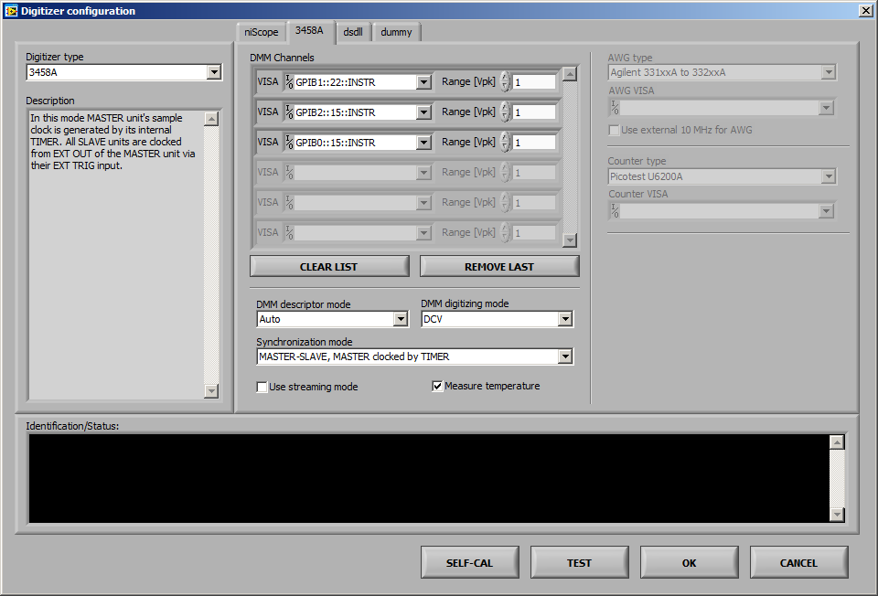

Fig. 3 - 3458A multimeters configuration panel.

If user wants to process the digitized data automatically, the GNU Octave/Matlab interface must be configured using button ‘Octave/Matlab’ on the main panel of TWM. The panel shown in the Fig. 4 will be displayed. In this panel, user must enter path to the binary folder of the GNU Octave installation. By pressing ‘Restart’ the Octave will be started. If successful the detected Octave version will be displayed. When calculation via QWTB toolbox is required, the user must set the path to the QWTB toolbox. By pressing ‘TEST QWTB’ the setup of the QWTB is verified.

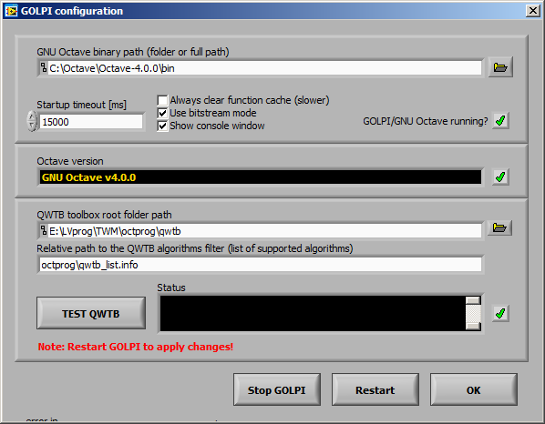

Fig. 4 - Octave/Matlab configuration panel.

When the basic configurations are done, the new measurement may be configured by pressing ‘SETUP MEASUREMENT’ or ‘SETUP & START’. This will initiate panel show in the Fig. 5. Here, user must setup sampling parameters such as samples count, sampling rate, triggers, etc. User must also setup destination folder for the measured data. User may also use variables in the file name which will be replaced by the automatic text. The actual destination folder with the replacements is always shown.

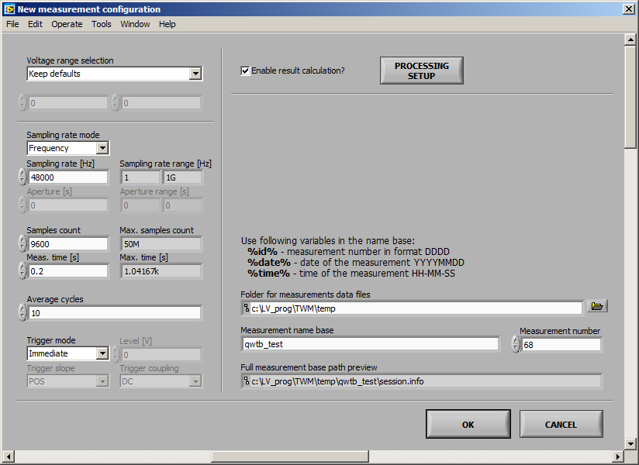

Fig. 5 - New measurement configuration.

If the calculation should be performed automatically on the recorded data, the user must also configure the processing using by pressing ‘PROCESSING SETUP’ and the checkbox ‘Enable result calculation?’ must be checked. The button ‘PROCESSING SETUP’ will invoke panel show in the Fig. 6 or Fig. 7. By selecting the page ‘RAW command’ a raw command mode is selected. In this mode, the TWM will execute the Octave/Matlab code placed in the text box as it is. Several ways of displaying the results are available.

If ‘QWTB’ page is selected, the TWM will execute the QWTB algorithm on the recorded data. In the QWTB mode, the ‘List of algorithms’ will be filled by the available algorithms. When the algorithm is selected, its information from QWTB toolbox will be displayed on the right. If the algorithm has user definable parameters, such as the one shown in the example in the Fig. 7, the list of the parameters will be shown in the table. User may fill the values. Each algorithm may have uncertainty calculation option, which must be selected if required.

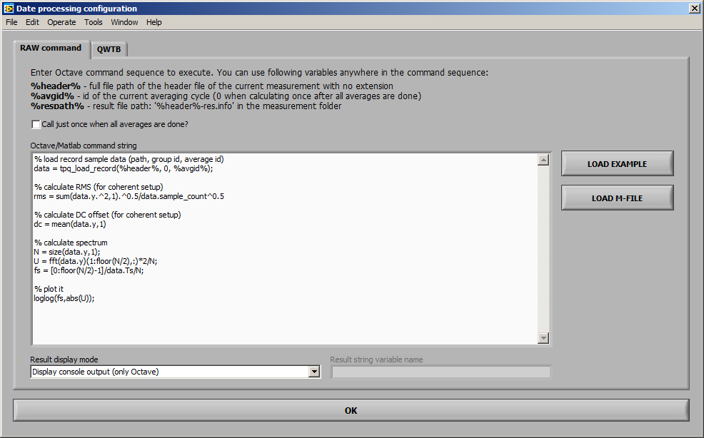

Fig. 6 - Configuration of the calculation (RAW commands mode).

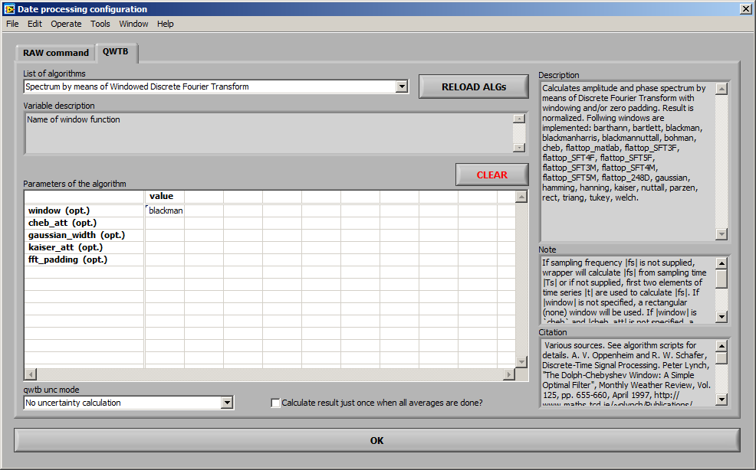

Fig. 7 - Configuration of the calculation (QWTB toolbox mode).

When the configuration of the measurement is done, user may initiate it by pressing ‘START’ on the main panel. When the record is done and eventual calculation is performed, the results are available on the main panel. In the ‘RAW command’ mode, the result is plain text. In the ‘QWTB’ node, the result is formatted table. User has several options, such as ordering the quantities, selecting the uncertainty display mode, etc. Each row of the table can be displayed as a graph by double clicking the row.

## References:

[1] EMPIR project TracePQM,   
www: <http://tracepqm.cmi.cz/>

[2] QWTB Toolbox,   
www: <https://qwtb.github.io/qwtb/>

[3] DirectSound DSDLL library,  
www: <http://www.elektronika.kvalitne.cz/SW/dsdll/dsdll_eng.html>

[4] GOLPI library – Gnu Octave to LabVIEW Pipe Interface,  
www: <https://github.com/KaeroDot/GOLPI>